Pozdravljeni!

Pri uri TJA morate pripraviti govorni nastop. Spodaj imate pripravljen miselni vzorec in besedišče, ki vam je lahko v pomoč.

Če ga še niste pripravili, potem izpolnite miselni vzorec in mi ga pošljite v vpogled.

Na mail mi napišite kdaj se dobimo na meet in pregledamo.

Talk about your summer
holiday…
ACTIVITIES
What did you do?

TRAVELLING
How did you get there?
How long did the journey take? ACCOMMODATION
Where did you stay?

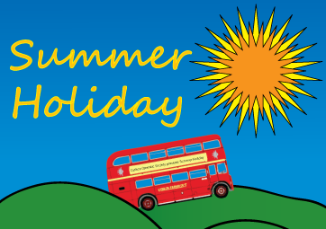
I WENT TO………………………………..

WEATHER PLACES
What was the weather like? Which places did you visit?
SHOPPING LIKES & DISLIKES
What did you buy? What did you enjoy most? Why?

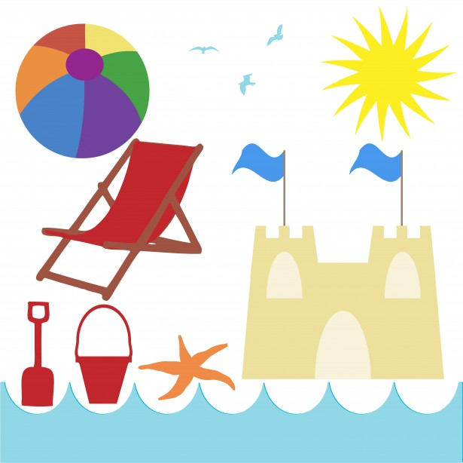
HOLIDAY VOCABULARY
BEACH VOCABULARY BEACH ACTIVITIES
Bathing suit I swam
Beach towel I built sand castles
Floats I sunbathed
Lounge chair I took some photos
Seashell I took long walks
Suntan lotion I collected seashells
Sand moulds I just relaxed
Goggles I snorkelled
Buckets I went fishing
Sand castles I went jogging
Sunglasses I sailed
Beach ball I surfed

ACCOMMODATION
Hotel
B&B
Campsite
Guesthouse
Cottage

SIGHTSEEING MEANS OF TRANSPORT
Ancient ruins Train
Romanesque church Bus
Gothic cathedral Coach
Royal palace Plane
Historic centre Ship
Town hall Boat
Abbey Bike
Medieval castle Motorbike
Fortress
Science museum
Art gallery
And now build questions to find out about my summer holiday…

……………………………? …………………………?

I went to Florence With my friend

……………………………?
We went by plane

………………………….? ………………………?
One week At a hotel

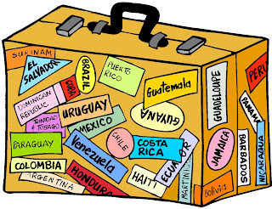

…………………………..? …………………………..?
The historic centre and the It was sunny and warm
Uffizi Gallery

………………………….? ………………………………?
A T-shirt, a bag and some The works of art and the food
postcards

