Pri uri TJA te čaka opis tvojega dne. Pošiljam ti primer opisa. Skušaj narediti še svojega. Ko ga narediš mi ga lahko pošlješ v vpogled, nato pa svetujem, da ga glasno bereš in si ga posnameš na telefon. Večkrat ga poslušaj, da si ga boš dobro zapomnil-a.

My Daily Routine
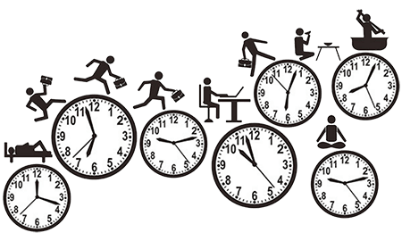
My name is XY. I’m eleven years old. I wake up at 7 o’clock every day except Saturday and Sunday. I wash, clean my teeth with a tooth-brush and comb my hair. Then I have breakfast. In the morning I like to eat fried eggs or cheese sandwich and drink tea. It takes me 10 minutes to get to school. My lessons begin at 7:30. At one o’clock the lessons are over. I usually have five or six lessons a day. I eat my lunch at school. I return home at 2 o’clock and have some rest. I watch TV and play computer games. Then I do my homework. After doing my homework I go for a walk with my friends. In the evening I go to the gym or take out my bike. My training lasts for an hour. My parents usually return home at 5 o’clock. We have dinner at 19:30. Then we sometimes go for a walk, spend time in the park or go shopping. Then I read books, newspapers and magazines, chat with friends on the phone. On Monday, Wednesday and Friday I attend (dance classes) (Football) (music classes). At 21.00 o’clock I take shower or a bath, brush m y teeth and go to bed.

